**Google BigQuery**

**Usage Guide**

**(Cloud Database)**

**(Setup Guide)**

**(Connection Guide)**

**Table Of Contents**

1. **Introduction……………………………….………….. 2**
2. **Signing Up……………………………………..….…. 2**
3. **Setup Guide………………..…………………..……. 3 - 6**
4. **Connecting To WinForms….………………..……. 7 - 8**
   1. **Codes..………..………………………………………….…. 7**
   2. **How To Use..…………………………………………….…. 8**
5. **Connecting To Spotfire…….………………..……. 9**
6. **References…….………………………………..……. 10 - 12**
   1. **Google Clou……………………………………………….…. 10**
   2. **Window Forms C#..…………………….…………..………. 10**
   3. **Google BigQuery…………………….....………………..…. 11**
   4. **Lanugages……………...………………………………… 12**
   5. **Additional C# Related…..……………………………… 12**

**1. Introduction**

This documentation report was requested to explain ONLY Google BigQuery. it will cover topics such as signing up, set up, and connect into TIBCO Spotfire and WinForms.

Before continuing this documentation, please have a read on the “Extending SpotfireDemo App” Documentation as it may also help understand more about using Google BigQuery..

**2. Signing Up**.

A Google Account is required to use Google BigQuery. Therefore, please create a Google Account before continuing this report. You can create an account [here](https://cloud.google.com/).

**3. Setup Guide**

After creating your Google Account, navigate to your Google Cloud Platform Console. Then open up the BigQuery service provided inside the Console.

Below I will explain the steps on how to open the BigQuery service, you may skip if you already understand.

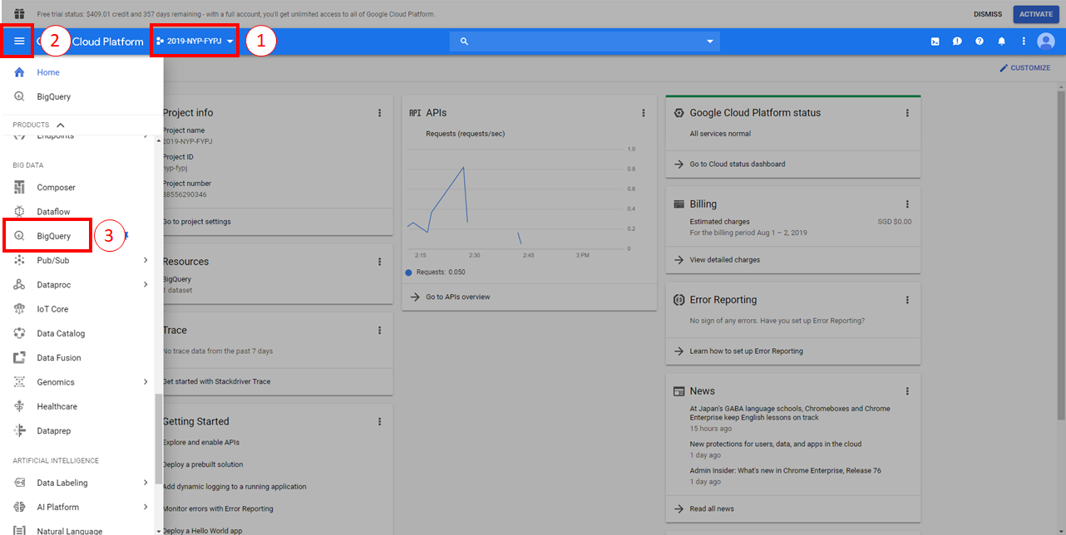

**In Step 1:**

At the very beginning of entering your Console, you must first select a project. Give it any name. Once created, you must associate a billing method (Enable billing for this project). This is essential to gain full access to Google BigQuery.

**In Step 2:**

Once your project is created with billing enabled, open your dashboard and scroll towards the “BIG DATA” section. Locate BigQuery and select it. You should also PIN the tab for future convenience.

**In Step 3:**

You will be visited with the GUI for Google BigQuery.

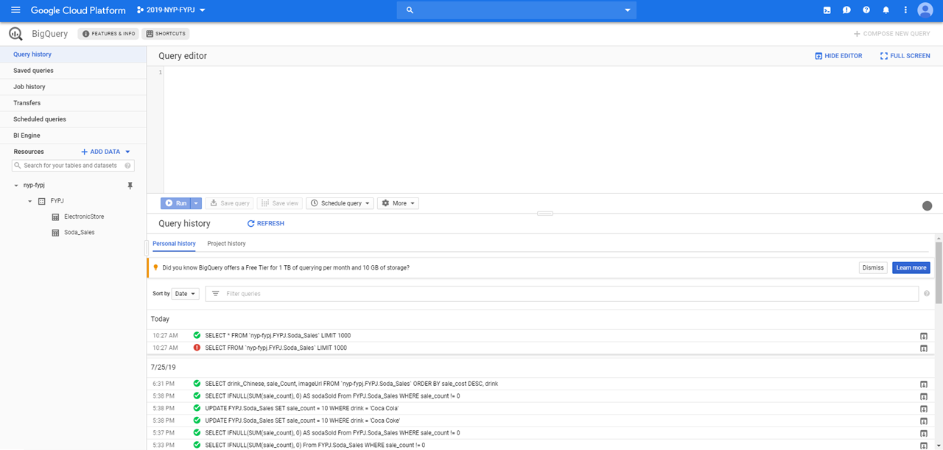

Create a simple DATASET with a TABLE with the GUI. To retrieve, modify or delete any data, you must use the Query Editor provided. You can also save your queries for future use.

As you require to use your own Google BigQuery account, I will provide the exact database used for this table. Copy the database table schema and data onto your own BigQuery Database. You may also use the Saved Queries as well.

**Database Schema:**

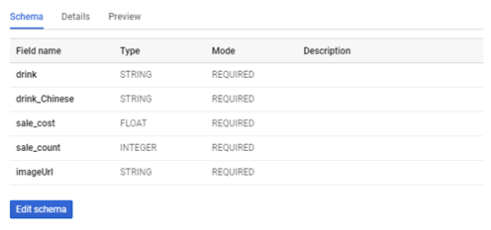

**Database Data:**

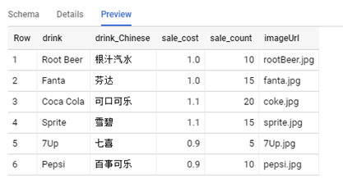

**Database Saved Queries:**

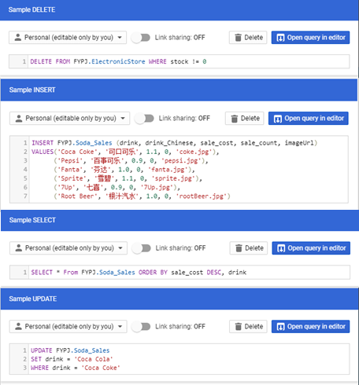

**Delete Sample:**

DELETE FROM FYPJ.ElectronicStore WHERE stock != 0

**Insert Sample:**

INSERT FYPJ.Soda_Sales (drink, drink_Chinese, sale_cost, sale_count, imageUrl)

VALUES('Coca Coke', '可口可乐', 1.1, 0, 'coke.jpg'),

('Pepsi', '百事可乐', 0.9, 0, 'pepsi.jpg'),

('Fanta', '芬达', 1.0, 0, 'fanta.jpg'),

('Sprite', '雪碧', 1.1, 0, 'sprite.jpg'),

('7Up', '七喜', 0.9, 0, '7Up.jpg'),

('Root Beer', '根汁汽水', 1.0, 0, 'rootBeer.jpg')

**Select Sample:**

SELECT * From FYPJ.Soda_Sales ORDER BY sale_cost DESC, drink

**Update Sample:**

UPDATE FYPJ.Soda_Sales

SET drink = 'Coca Cola'

WHERE drink = 'Coca Coke'

**Finale:**

Once completed, your database is ready to be used. However, to use the database you must first create a user credential .json file. The file will be used to connect into any coding project.

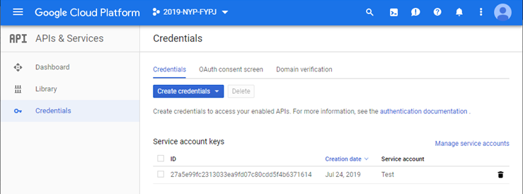

Using the navigation menu, go to “APIs & Services > Credentials”. Then click on “Create credentials > Service account key”. Follow the prompts accordingly to create the service account key.

When creating the service account key, download the json file that is associated with the created service account and save it. This json file will act as your Google Credentials to access the BigQuery.

**4. Connecting To WinForms**

From the original Spotfire Demo App - FruitStore, I have created a demo utilizing Google BigQuery as a cloud database source. You can access this demo by running the Spotfire Demo App and selecting the “Soda Sales (BigQuery) to have a glimpse of the demo.

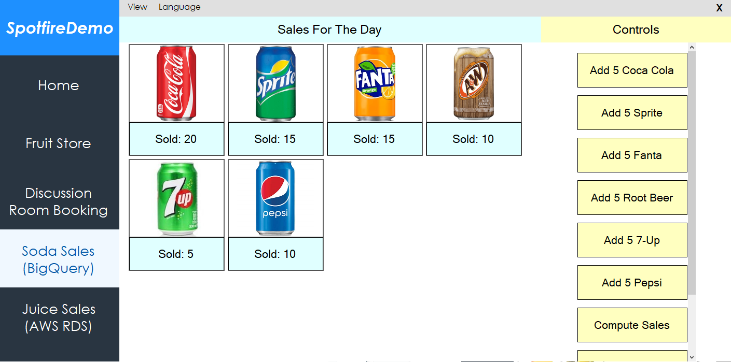

As the demo uses Google BigQuery to store its data, you may only view the data via the Google BigQuery Query Editor.

**4.1 Codes**

By opening the source codes of the project file “SpotfireDemo.cs” and “BigQuery.cs”, you can see the codes to connect to the cloud database and to call/update the cloud database, respectively. This puts the previously mentioned .json file into play.

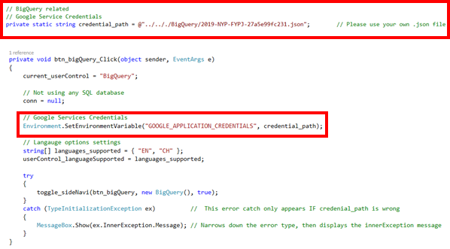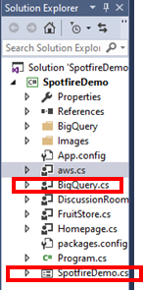

As the demo codes are lengthy and complicated, it is best to explore the source codes yourself. Comments are provided inside the source codes already to further learn how the program works. **Note**: You require to provide your own working account credentials to use the demo.

**4.2 How To Use**

After opening the main page of the demo, the functionality of this demo works very similar to the FruitStore Demo. At the side, use the controls to add items, reset the items, and use an existing preset.

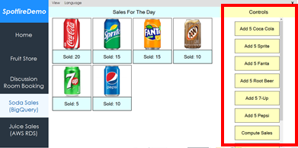

Whenever the data is changed, it will be reflected at the Google BigQuery Console. Use a simple SELECT statement to view the changes to the data.



**5. Connecting To Spotfire**

The final step is to link to Spotfire and create visualisations with this demo. First, open up your Spotfire. Then, create a connection with Google BigQuery.

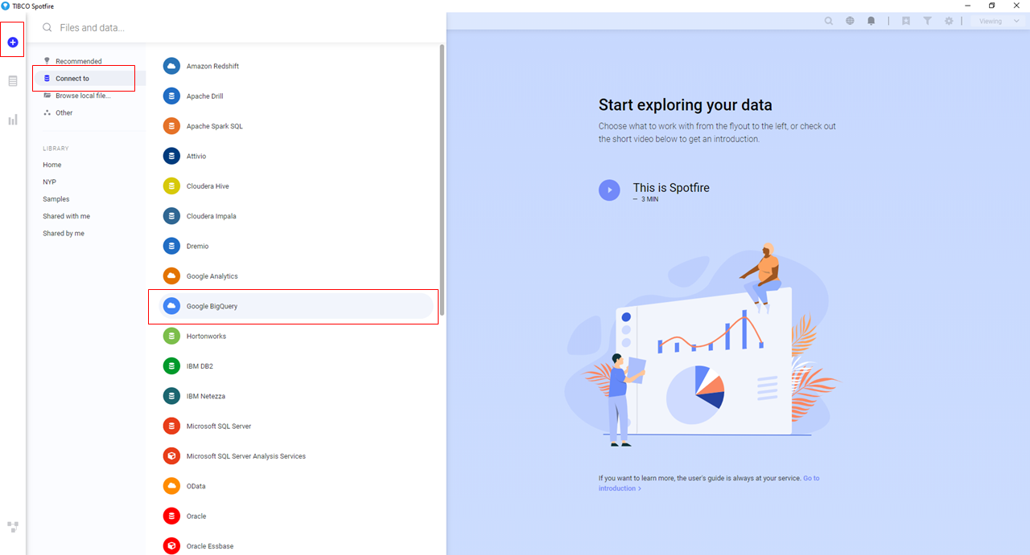

After creating your Analysis, play around with the visual options and create your own visualisation set. An example of my visualisation setis shown below.

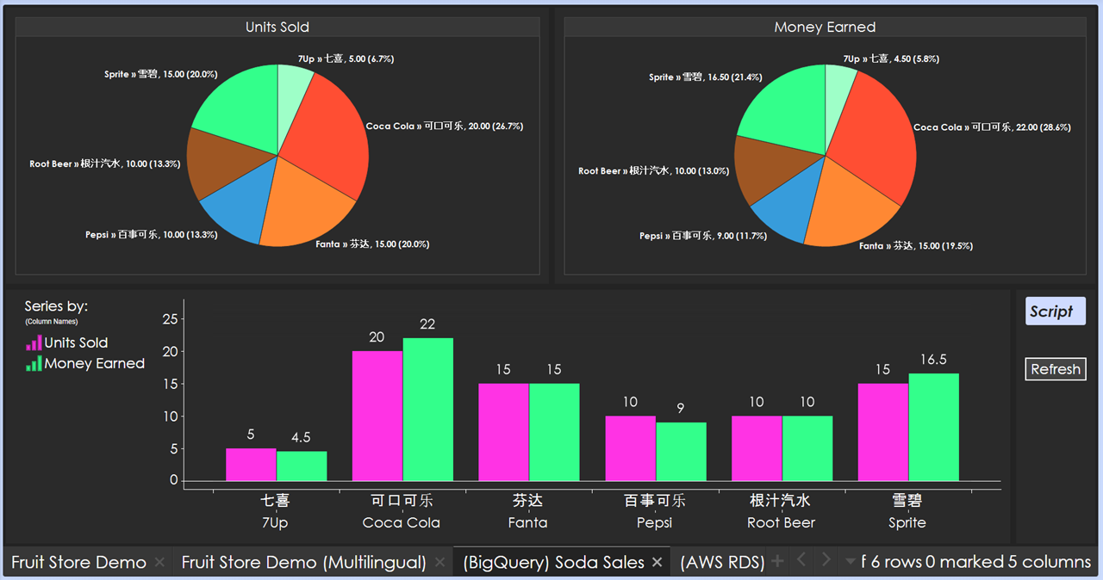

**6. References**

**6.1 Google Cloud**

Google Cloud:

<https://cloud.google.com/>

**6.2 Window Forms C#**

Duplicate WinForms form: <https://stackoverflow.com/questions/1268591/how-to-easily-duplicate-a-windows-form-in-visual-studio>

Programmatic Button Click:

<https://stackoverflow.com/questions/16792160/how-to-trigger-a-button-click-in-my-code>

C# ArrayList:

<https://www.geeksforgeeks.org/c-sharp-arraylist-class/>

<https://www.tutorialspoint.com/csharp/csharp_arrays>

ArrayList Check Value Exist:

<https://stackoverflow.com/questions/7867377/checking-if-a-string-array-contains-a-value-and-if-so-getting-its-position>

Array IsNullOrEmpty:

<https://stackoverflow.com/questions/8560106/isnullorempty-equivalent-for-array-c-sharp>

Foreach Loop:

<https://docs.microsoft.com/en-us/dotnet/csharp/language-reference/keywords/foreach-in>

Round 2 Decimal:

<https://stackoverflow.com/questions/164926/how-do-i-round-a-decimal-value-to-2-decimal-places-for-output-on-a-page>

Convert String To Float:

<https://stackoverflow.com/questions/11202673/converting-string-to-float-in-c-sharp>

InnerException property of TypeInitializationException:

<https://stackoverflow.com/questions/4398334/the-type-initializer-for-myclass-threw-an-exception>

Get Number Of Rows With SqlDataReader:

<https://stackoverflow.com/questions/1383315/how-to-get-number-of-rows-using-sqldatareader-in-c-sharp>

**6.3 Google BigQuery**

**6.3.1 Pricing**

Pricing:

<https://cloud.google.com/bigquery-ml/pricing>

**6.3.2 Official Notes**

Using BigQuery Sandbox:

<https://cloud.google.com/bigquery/docs/sandbox?hl=en_US&_ga=2.46468704.-610591827.1563784934&_gac=1.150467908.1563784965.Cj0KCQjwvdXpBRCoARIsAMJSKqJ3Kd73OClcWE4Q04qraecFAQ9bWDTJoOArYWU0l6QCZIIviJm5mT4aAjnEEALw_wcB>

Wildcard Tables:

<https://cloud.google.com/bigquery/docs/reference/standard-sql/wildcard-table-reference>

Data Manipulation Language (DML) Syntax:

<https://cloud.google.com/bigquery/docs/reference/standard-sql/dml-syntax>

BigQuery Classic Web UI:

<https://cloud.google.com/bigquery/docs/bigquery-classic-ui>

Google.Cloud.BigQuery.V2 Demo Codes:

<https://googleapis.github.io/google-cloud-dotnet/docs/Google.Cloud.BigQuery.V2/index.html>

BigQuery Client Library Setup:

<https://cloud.google.com/bigquery/docs/reference/libraries>

**6.3.3 Community Notes**

SQL Cheat Sheet:

<http://www.sqltutorial.org/sql-cheat-sheet/>

C# .NET Google Application Credentials JSON file:

<https://stackoverflow.com/questions/37626200/c-sharp-net-mvc-set-path-to-google-application-credentials-json-file>

BigQuery w/ C# .NET Simple Installation Guide:

<https://medium.com/@gabriel.faraday.barros/asp-net-core-api-google-bigquery-bd69c4fde45b>

Using BigQuery with C# Video:

<https://www.youtube.com/watch?v=zOjOg_Lp5Nc>

SELECT return default: <https://stackoverflow.com/questions/11503463/how-to-return-default-value-from-sql-query>

INSERT statement:

<https://www.w3schools.com/sql/sql_insert.asp>

**6.4 Language**

Drinks in Chinese:

<https://blogs.transparent.com/chinese/chinese-vocabulary-drinks/>

<https://www.fluentu.com/blog/chinese/2013/03/08/essential-chinese-vocabulary-word-list-drinks/>

<https://blogs.transparent.com/chinese/get-your-drink-on/>

**6.5 Additional C# Related**

Array Reverse Method:

<https://docs.microsoft.com/en-us/dotnet/api/system.array.reverse?view=netframework-4.8>

ListBox Word Wrap alternative:

<https://social.msdn.microsoft.com/Forums/vstudio/en-US/9b69fcd9-e9af-4f06-96e9-f164ee6e5428/list-box-word-wrap?forum=vbgeneral>

String.Replace() Method:

<https://www.geeksforgeeks.org/c-sharp-replace-method/>

Foreach Loop, Find Last Iteration:

<https://stackoverflow.com/questions/7476174/foreach-loop-determine-which-is-the-last-iteration-of-the-loop>

Parse Strings Using String.Split:

<https://docs.microsoft.com/en-us/dotnet/csharp/how-to/parse-strings-using-split>

Convert Double To Nearest Integer:

<https://stackoverflow.com/questions/633335/how-might-i-convert-a-double-to-the-nearest-integer-value/633340>

Generate Random Int Number:

<https://stackoverflow.com/questions/2706500/how-do-i-generate-a-random-int-number>

Generate Random Alphanumeric String:

<https://stackoverflow.com/questions/1344221/how-can-i-generate-random-alphanumeric-strings>